Amazon RDS PostgreSQL to OCI PostgreSQL Zero-Downtime Migration Whitepaper V4
Author :
Shadab Mohammad,
Cloud Solutions Architect, Centre of Excellence JAPAC
shadab.mohammad@oracle.com

Source Environment :
Amazon RDS for Postgres
Version : Postgres14.9
Dbname : postgres
Schema : public
User : postgres

Target Environment :
OCI Postgres Service
Version : Postgres14.9
Dbname : postgres
Schema : public
User : postgres

Network Infra Setup:
- Create a VM on OCI, which has connectivity to both AWS RDS source instance and OCI Target instance
- Install Postgres client on the VM
- Ensure the bandwidth between your AWS VPC and OCI VCN is good enough to copy over large data across the network
- Port TCP/5432 rules should be whitelisted on both AWS and RDS.

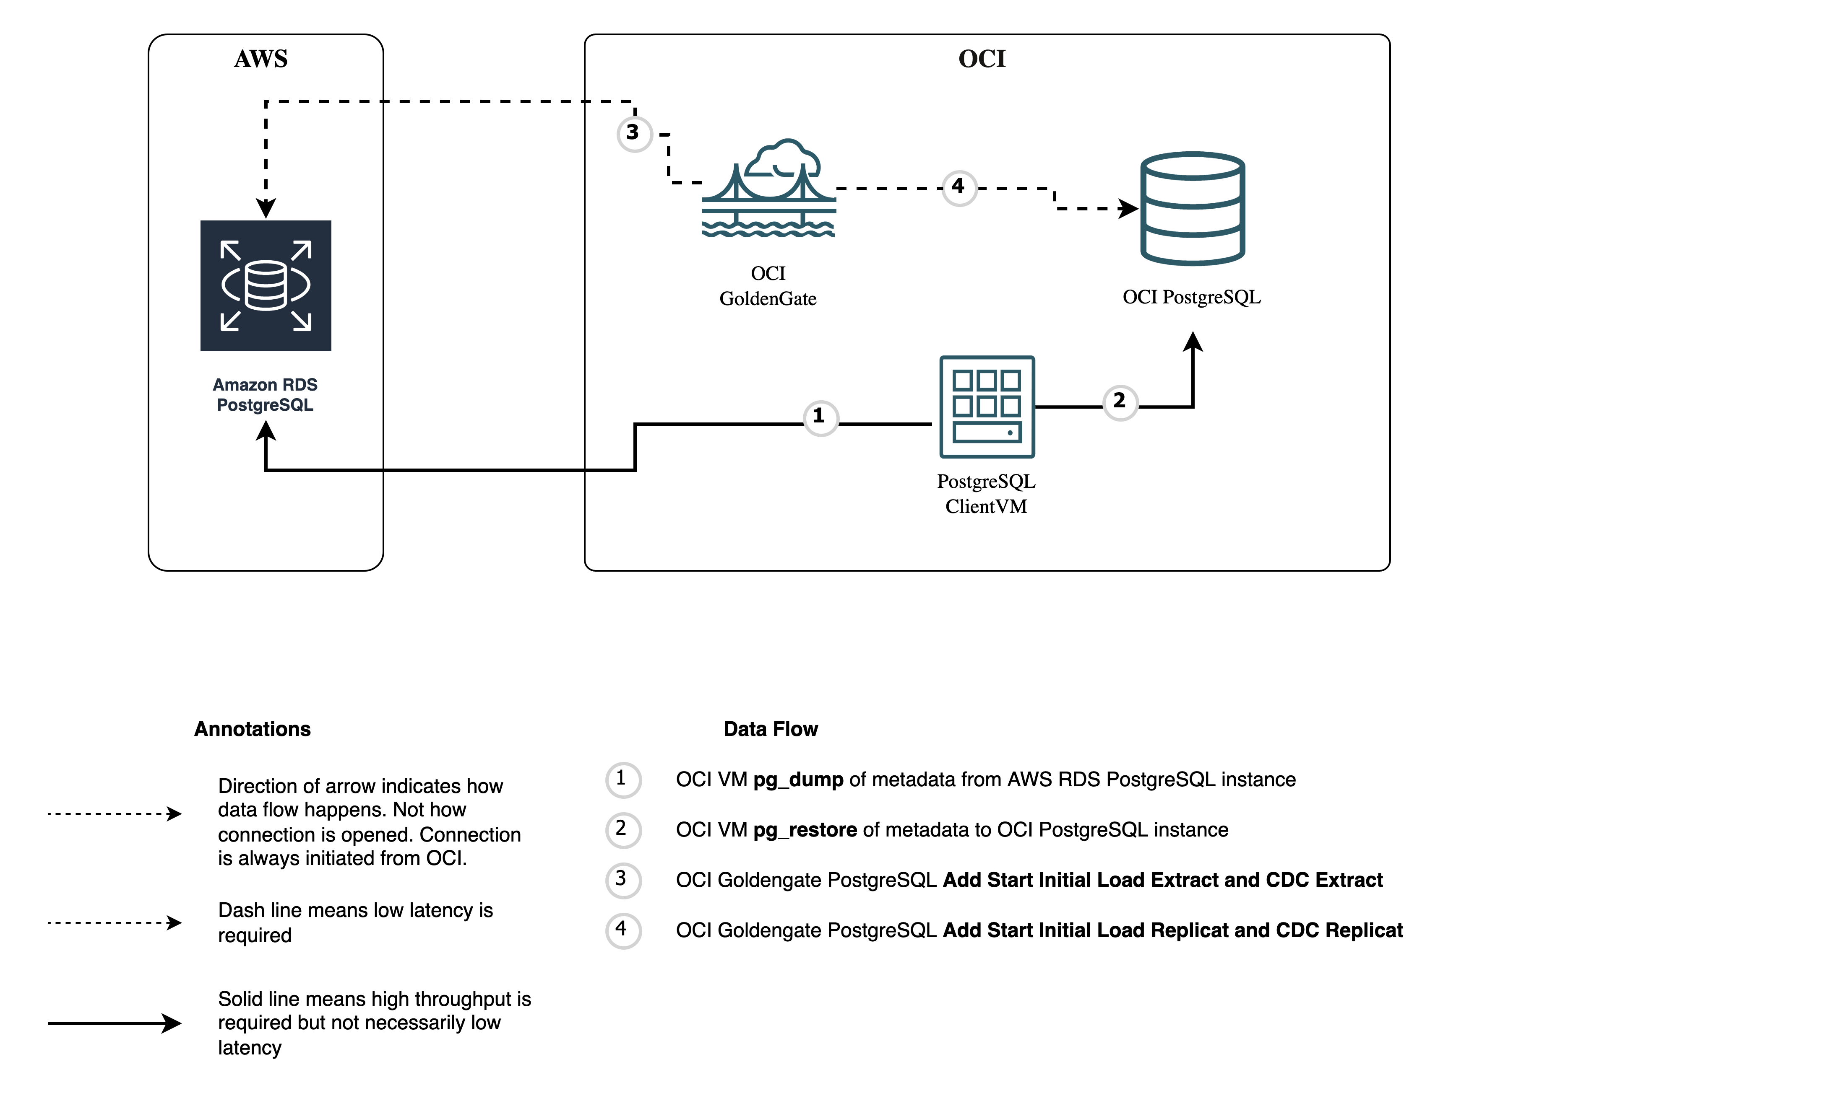

Important:
Create a new parameter group with parameter rds.logical_replication value set to 1 for the AWS RDS Postgres instance
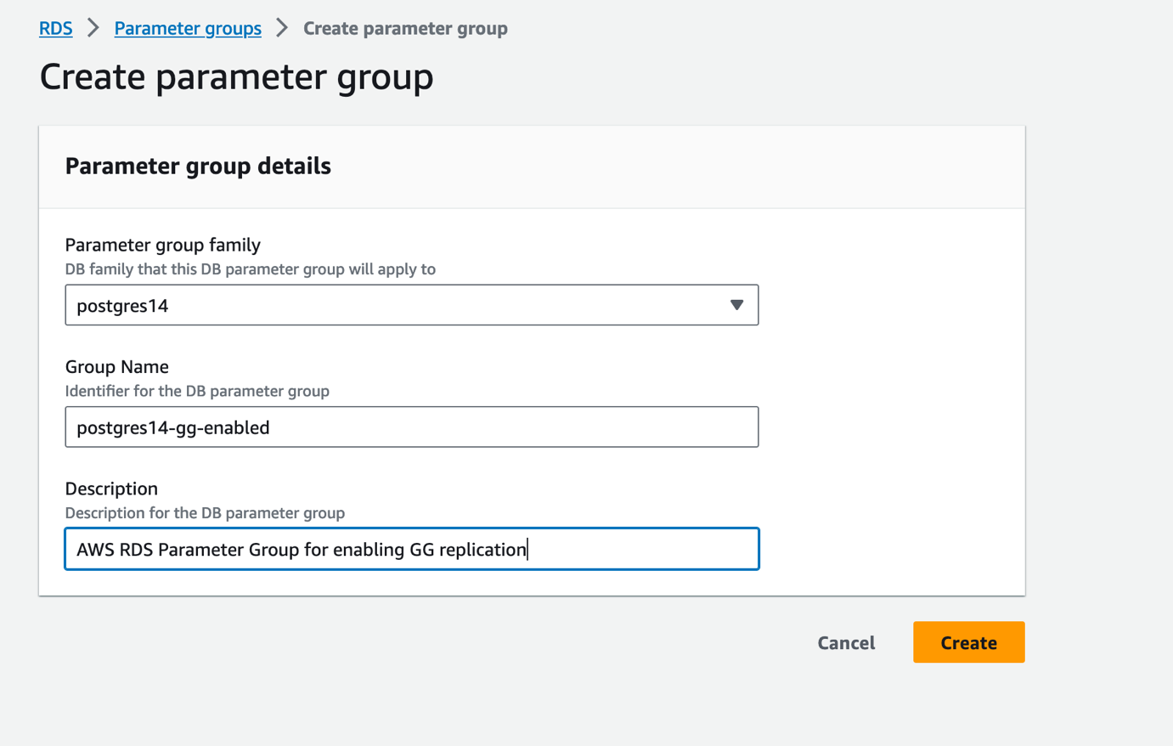

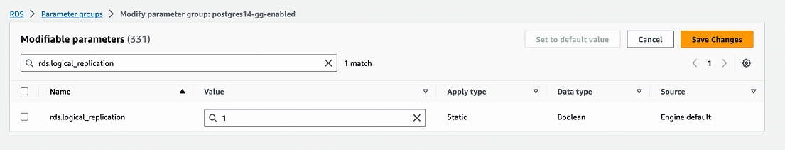

For Production DB migration, you will also have to change other WAL parameters. Check for parameters for Postgres version using :

aws rds describe-db-parameters --db-parameter-group-name default.postgres14
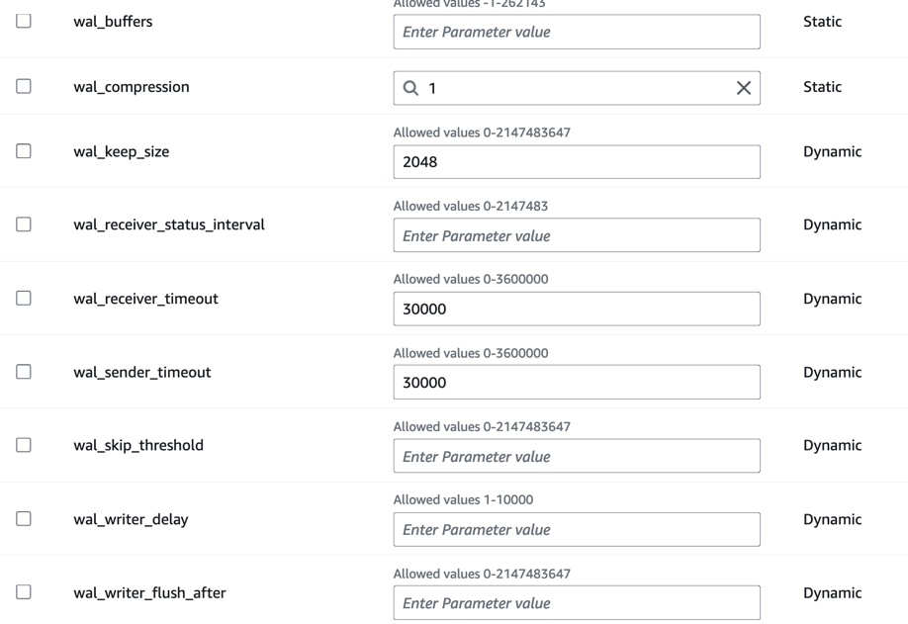
High-level Steps:

- Create pg_dump file from AWS RDS for source metdata
- Import metadata file into OCI Postgres using pg_restore
- Create OCI Postgres GG Deployment and create connections to both AWS RDS (S) and OCI Postgres (T)
- Add Trandata for Source Database Tables and Checkpoint Table to Target Database
- Create an Initial Load Extract on AWS RDS Pgsql (S) and note the LSN number.
- Create a CDC Extract on AWS RDS Pgsql (S) and start from the LSN number in step 4.
- Create an Initial Load Replicat on OCI Pgsql (T) using the same trail file as step 4.
- Create a CDC Replicat on on OCI Pgsql (T) using the same trail file as step 5.

Step-by-Step:

1. Create pg_dump file from AWS RDS for source metdata

a. We’re using the DVDRental Sample database for this exercise

Download DVDRental database from : https://neon.tech/postgresql/postgresql-getting-started/postgresql-sample-database

unzip dvdrental.zip
inflating: dvdrental.tar

psql -h postgres.ctvj2nl8rg0a.ap-southeast-2.rds.amazonaws.com -U postgres -d postgres

create database dvdrental;

pg_restore -h 10.180.2.228 -U postgres -d dvdrental dvdrental.tar

psql -h postgres.ctvj2nl8rg0a.ap-southeast-2.rds.amazonaws.com -U postgres -d dvdrental

postgres=> \c dvdrental

dvdrental=> \dt

b. Take metadata dump for entire database

pg_dump -h postgres.ctvj2nl8rg0a.ap-southeast-2.rds.amazonaws.com -U postgres -d dvdrental -Fd -b -v -s -j 4 --file= dvdrental_schema
- -h your_host: Replace your_host with the hostname or IP address of your PostgreSQL server.
- -U your_user: Replace your_user with the username you use to connect to the database.
- -d your_database: Replace your_database with the name of the database you want to dump.
- -Fd : Specifies the directory format for the dump.
- -b: Includes large objects in the dump.
- -v: Verbosely prints the output.
- -j: Parallel jobs. Run the dump in parallel by dumping tables simultaneously. This option may reduce the time needed to perform the dump but it also increases the load on the database server. pg_dump will open njobs + 1 connections to the database, so make sure your max_connections setting is high enough to accommodate all connections.
- -s or --schema-only: Dumps only the schema (metadata) without data.
- --file= dvdrental_schema: Specifies the output directory for the dump. Replace dvdrental_schema with the desired directory name.
2. Import Metadata dump file into OCI Postgres
pg_restore -h 10.150.2.142 -U postgres -d dvdrental -v -j 4 dvdrental_schema

  - -j number-of-jobs Run the most time-consuming steps of pg_restore — those that load data, create indexes, or create constraints — concurrently, using up to number-of-jobs concurrent sessions. This option can dramatically reduce the time to restore a large database to a server running on a multiprocessor machine. pg_restore will open njobs + 1 connections to the database, so make sure your max_connections setting is high enough to accommodate all connections.
- -h your_host: Replace your_host with the hostname or IP address of your OCI PostgreSQL server.
- -U your_user: Replace your_user with the username you use to connect to the database.
- -d your_database: Replace your_database with the name of the database you want to restore to.
  - -v : verbose

3. Create OCI Postgres GG Deployment and add connections to both AWS RDS (S) and OCI Postgres (T)

https://docs.oracle.com/en/cloud/paas/goldengate-service/bozng/

Create Source AWS RDS Postgres connection
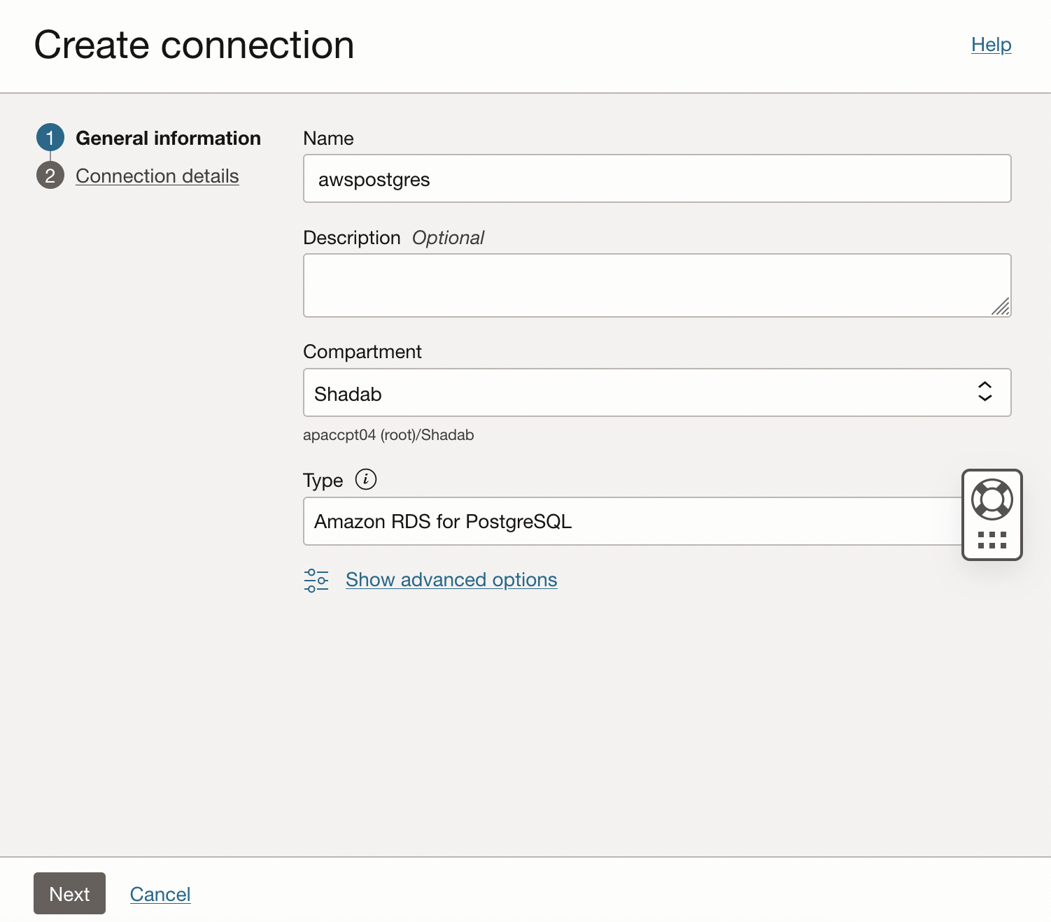

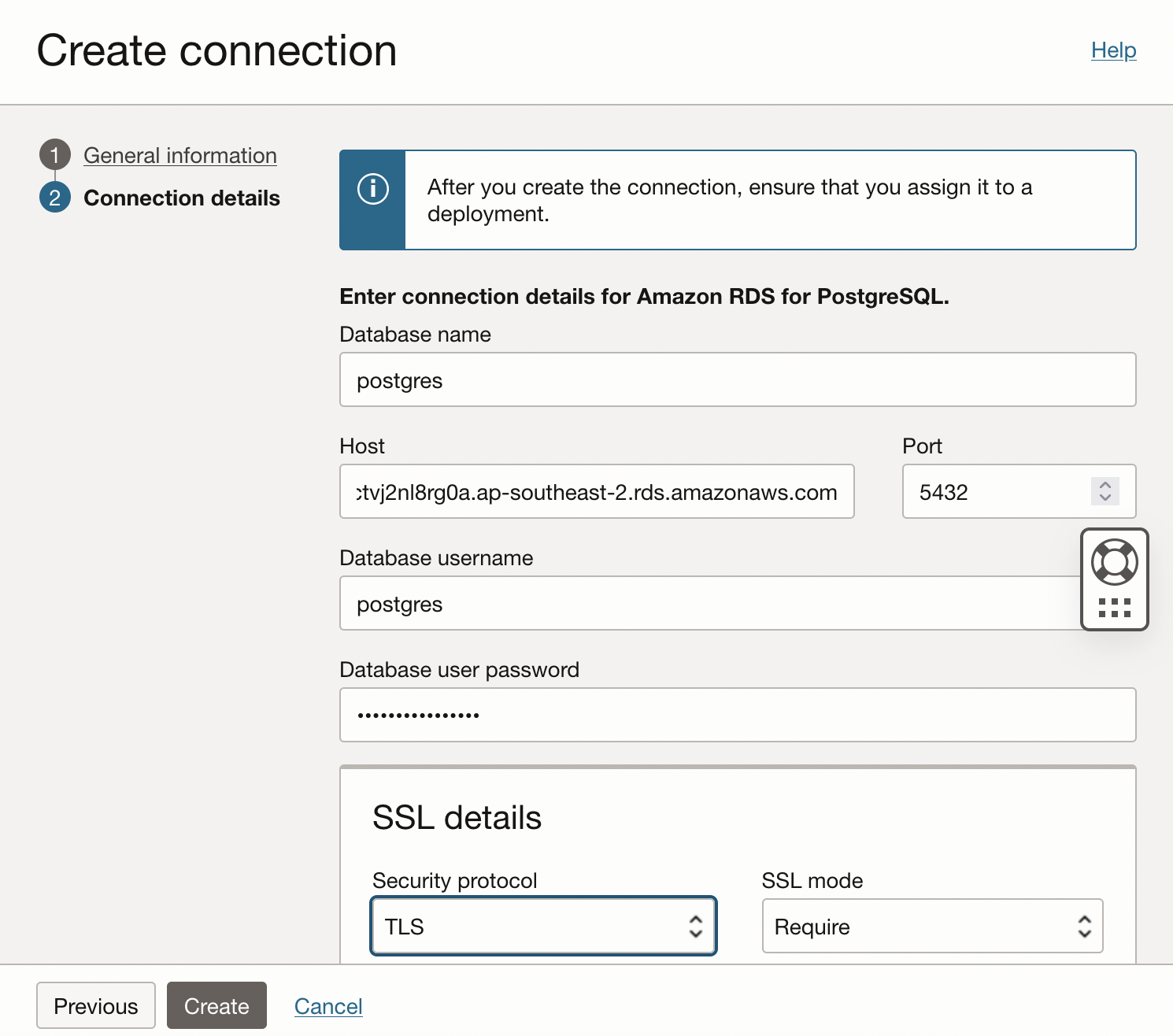

Create Target OCI Postgres connection
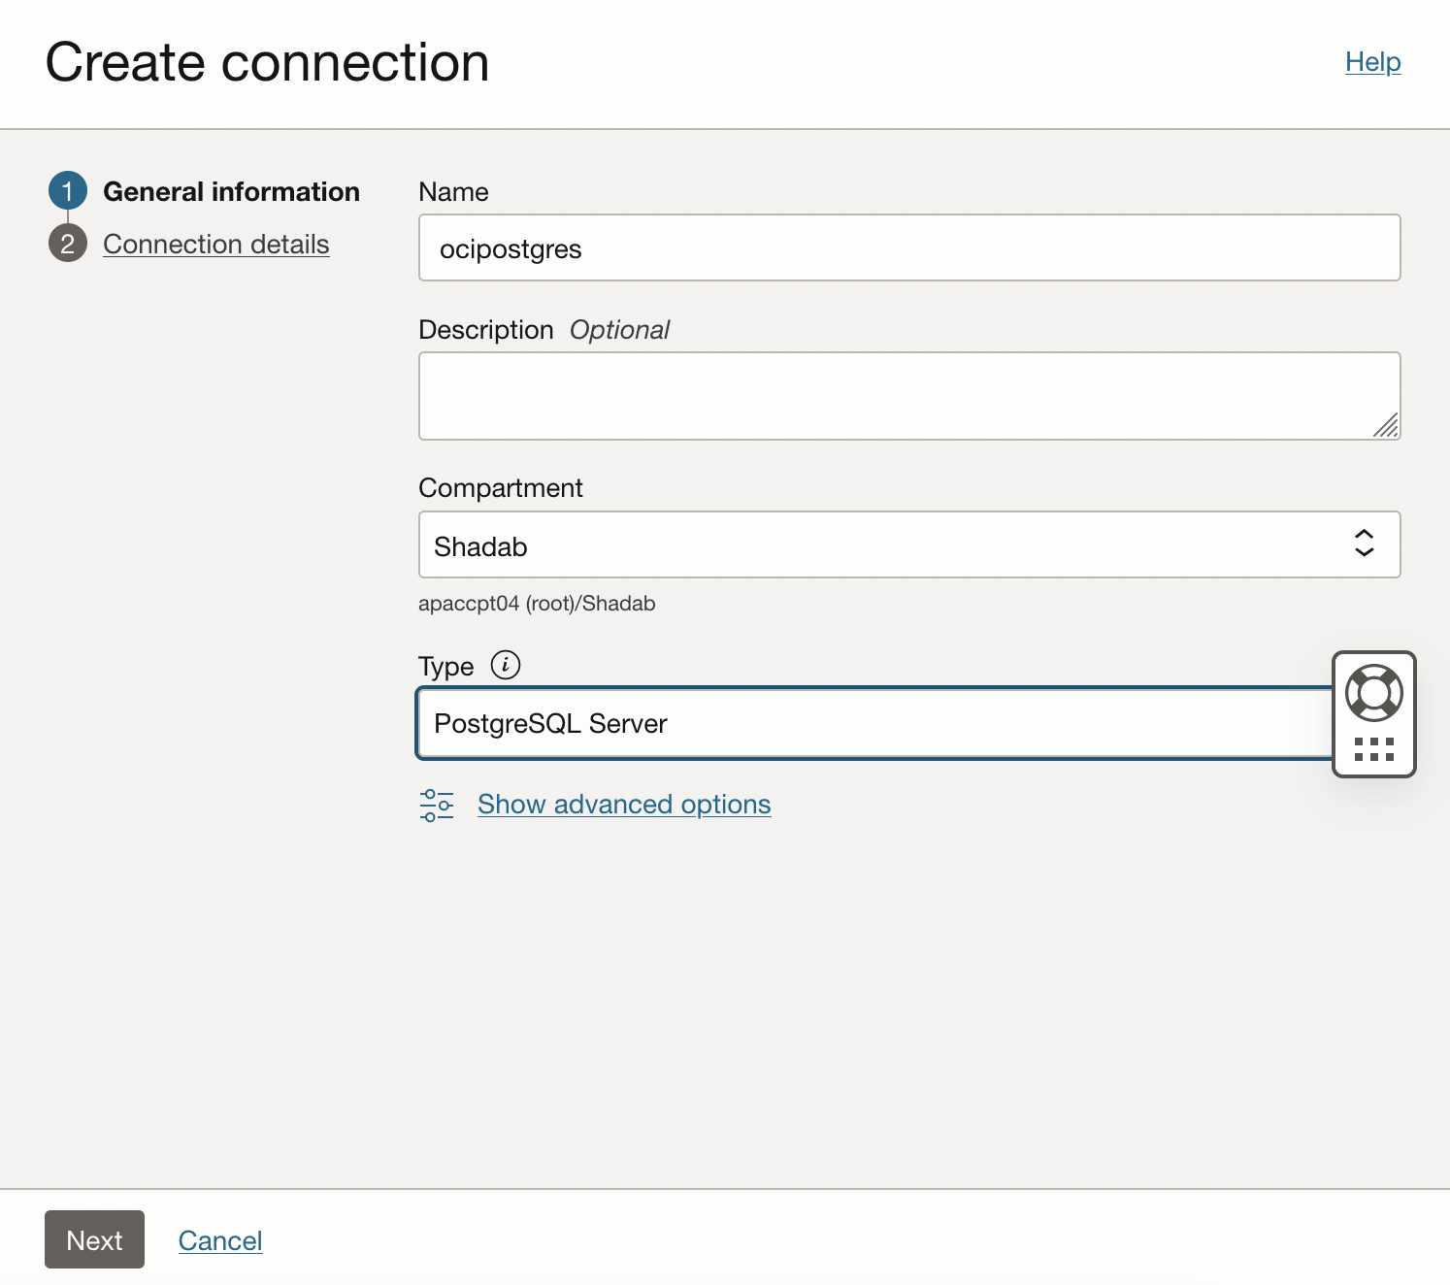

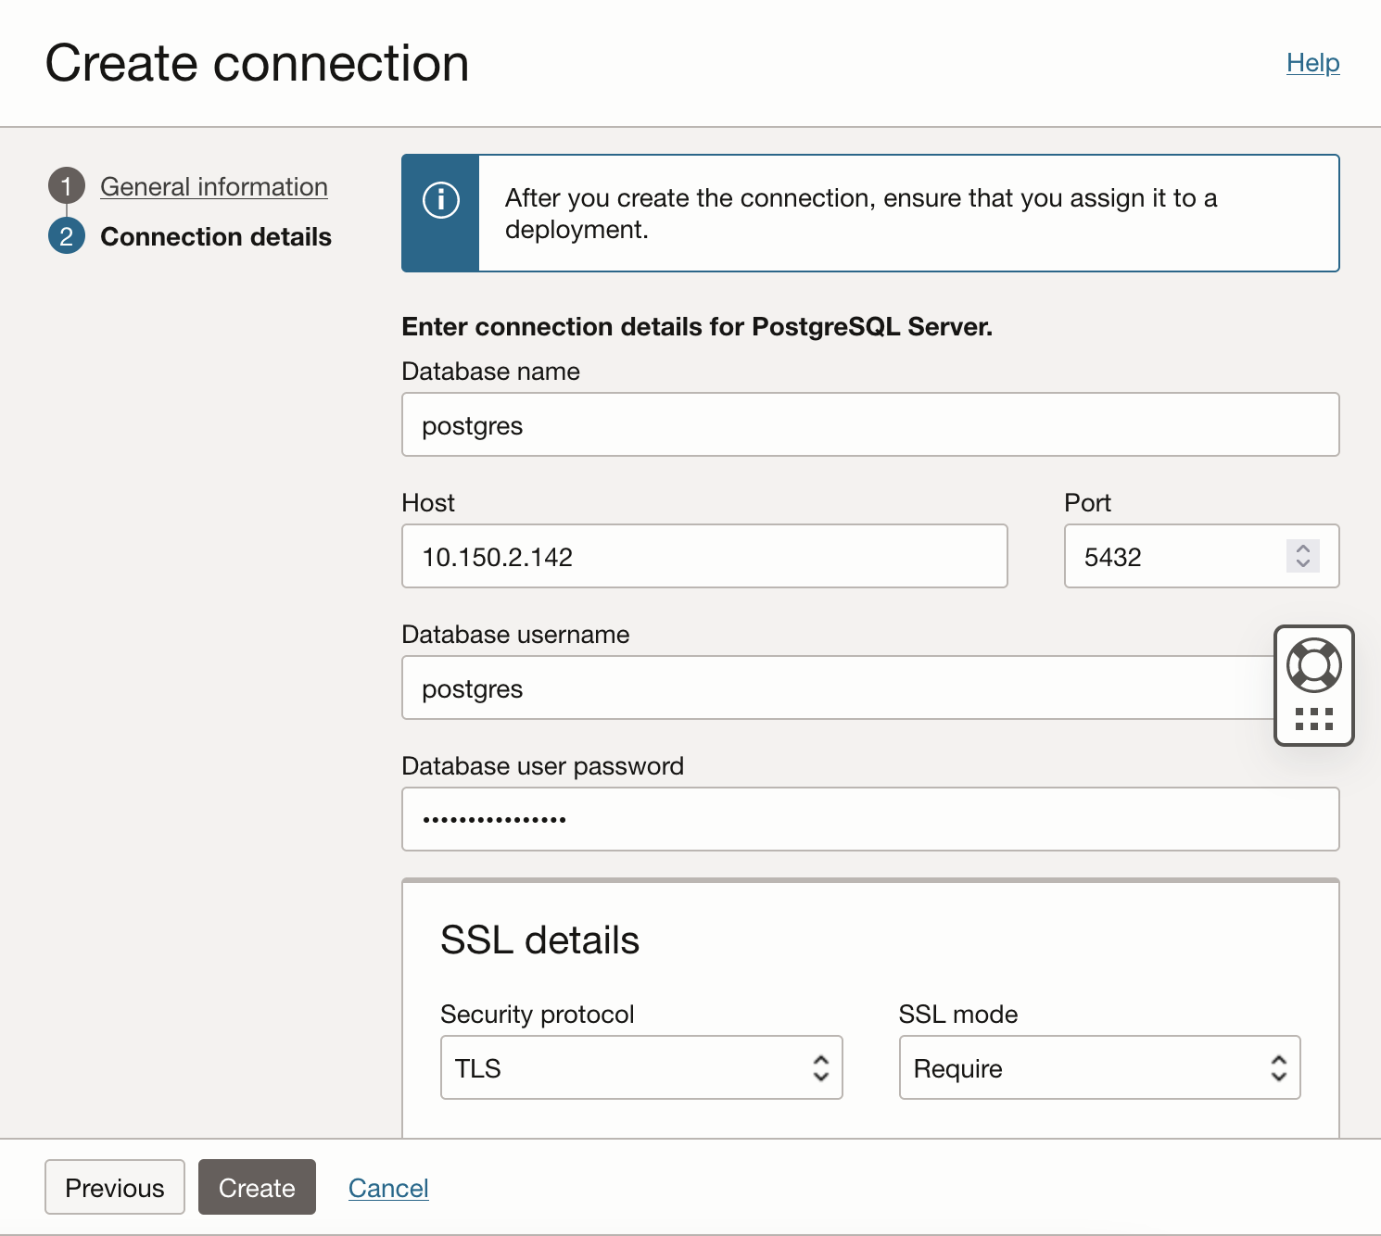
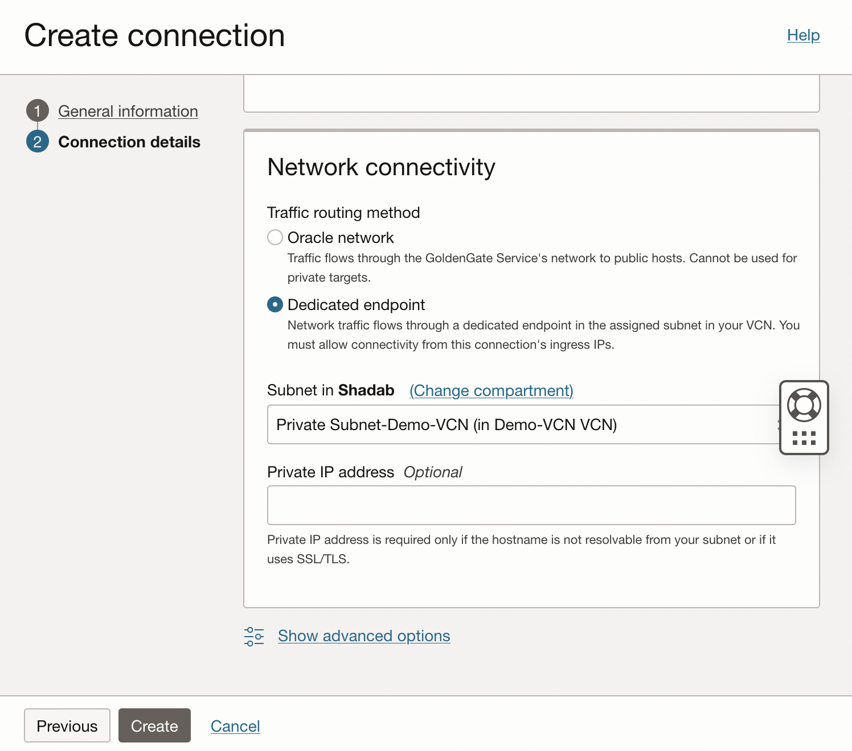

4.Create an Initial Load Extract on AWS RDS pgsql (S) and note the LSN number

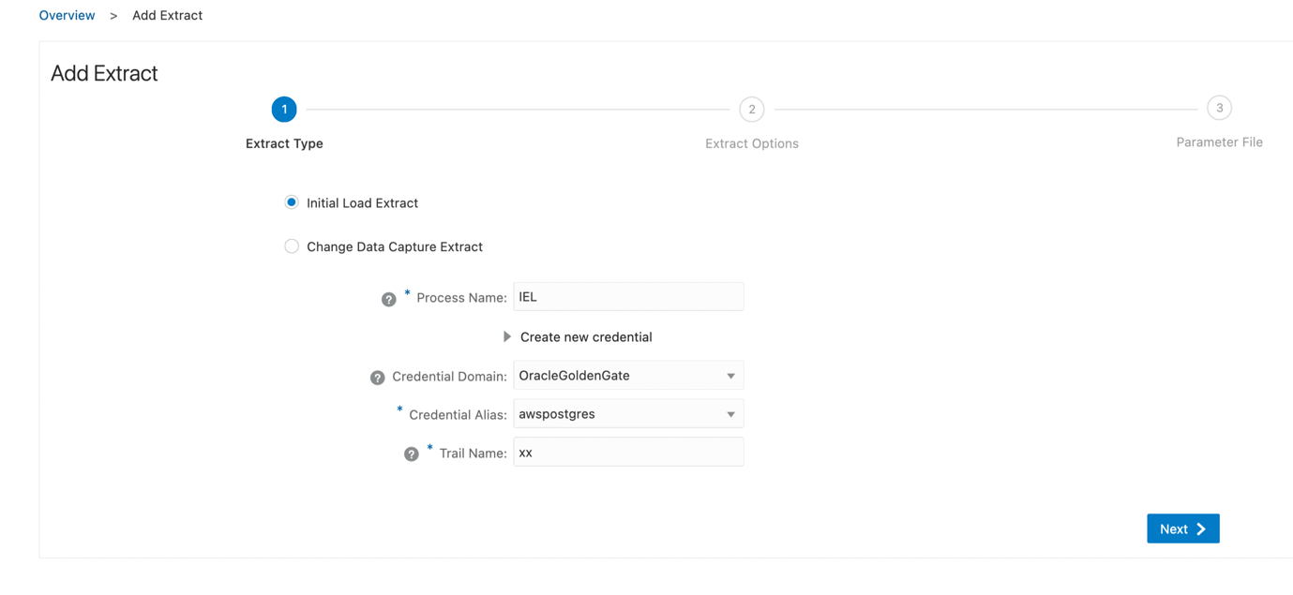
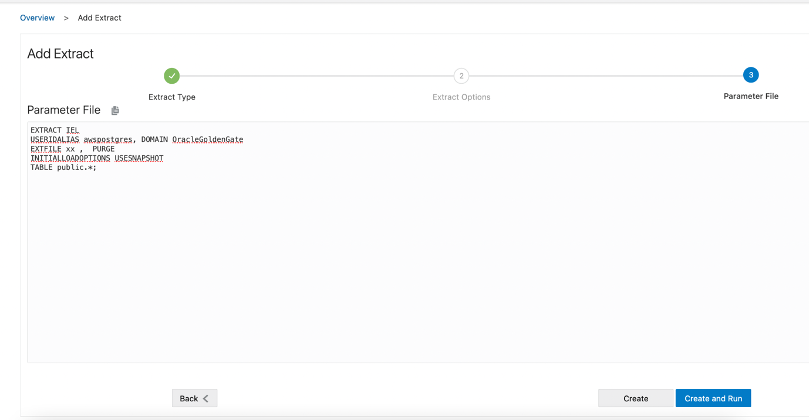
INITIALLOADOPTIONS USESNAPSHOT parameters are quite important and must be added to ensure we can get a consistent snapshot of the DB after the initial load extract completes along with the LSN number.
Check the report file after the extract completes and you can see the LSN number in there.
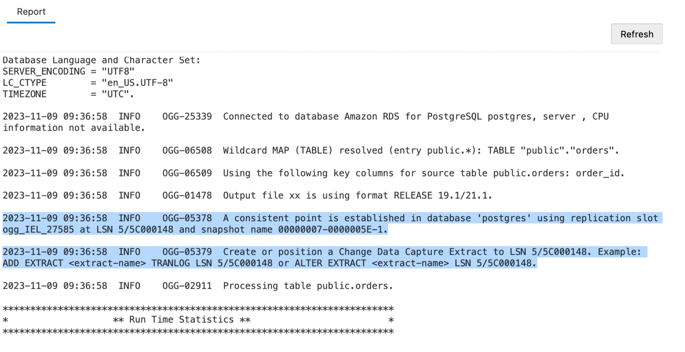
2023-11-09 09:36:58 INFO OGG-05378 A consistent point is established in database 'postgres' using replication slot ogg_IEL_27585 at LSN 5/5C000148 and snapshot name 00000007-0000005E-1.

2023-11-09 09:36:58 INFO OGG-05379 Create or position a Change Data Capture Extract to LSN 5/5C000148. Example: ADD EXTRACT <extract-name> TRANLOG LSN 5/5C000148 or ALTER EXTRACT <extract-name> LSN 5/5C000148.

5.Create a CDC extract on AWS RDS pgsql (S) and start from the LSN number from step 4, LSN 5/5C000148
First, add Trandata to the Source RDS Postgres table or all tables in source schema.
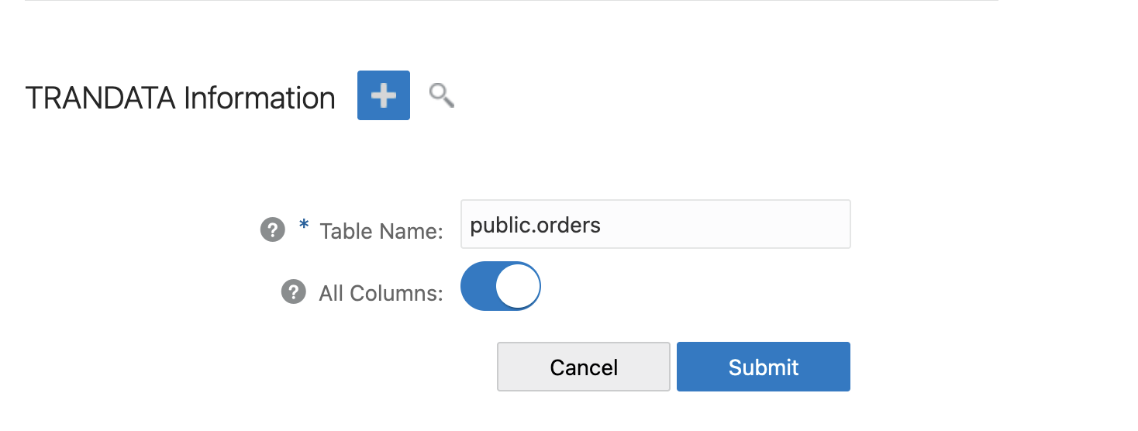

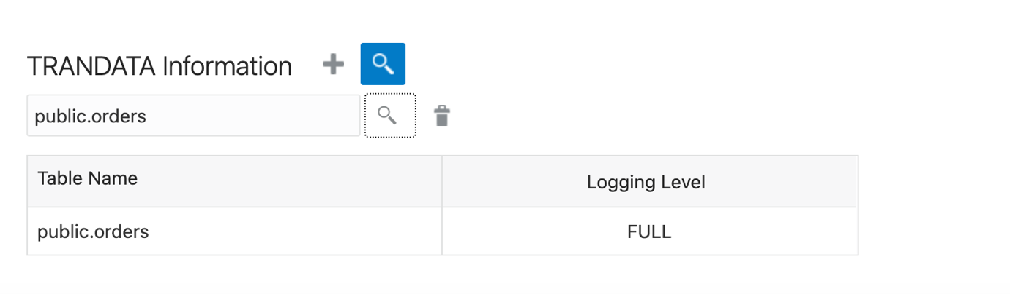

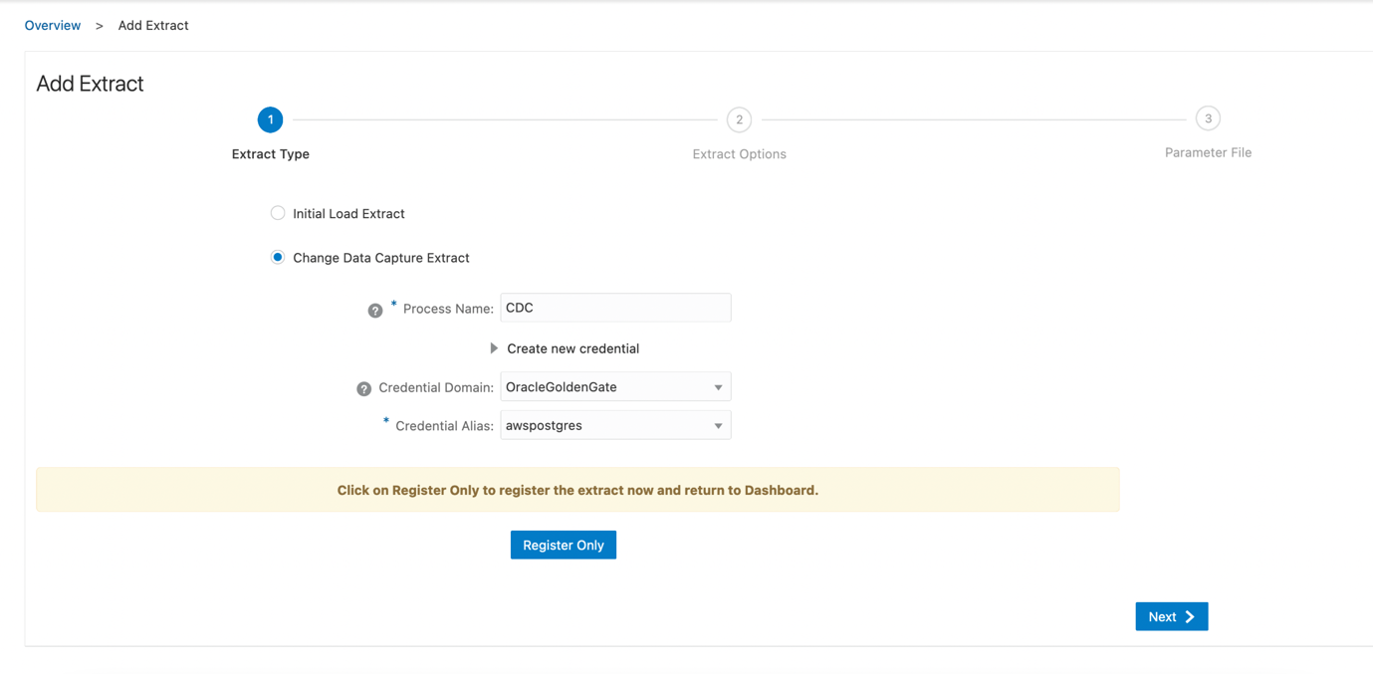

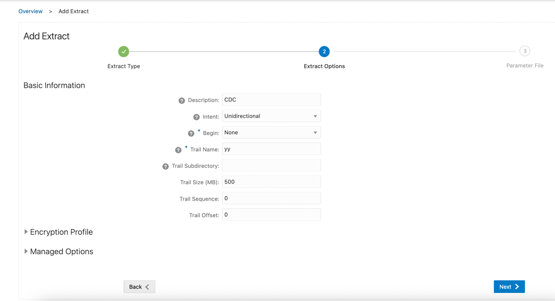
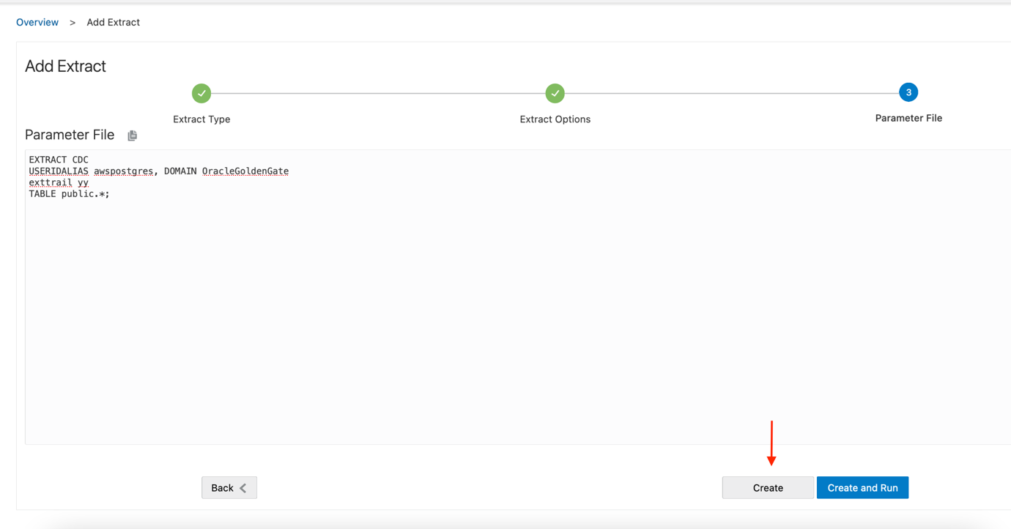

Edit the Extract from Action > Details > Start With option and enter the LSN number: 5/5C000148 from Step 4

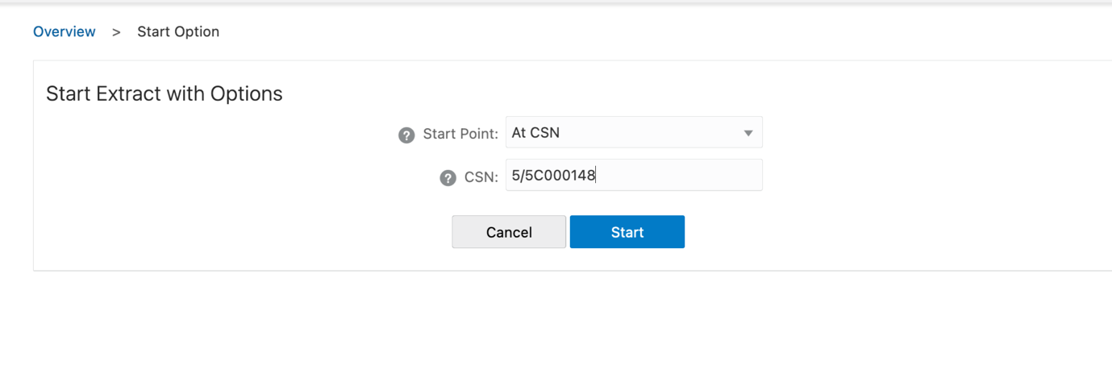

In the report file of the cdc extract you can see the message

2023-11-09 09:56:11 INFO OGG-25376 Oracle GoldenGate capture 'CDC' running with replication slot 'cdc_23e20f32ed48e7dd', slot type 'logical', plugin name as 'test_decoding' attached with database 'postgres' with slot restart LSN as '5/680003B8', flush LSN as '5/680003F0' and its current TXID as '1222'.
Generate some transactions on the RDS DB
postgres=> SELECT add_random_orders(20000);
add_random_orders
----------------------------
20000 random orders added.
(1 row)

You can see these transactions in the statistics of the cdc extract
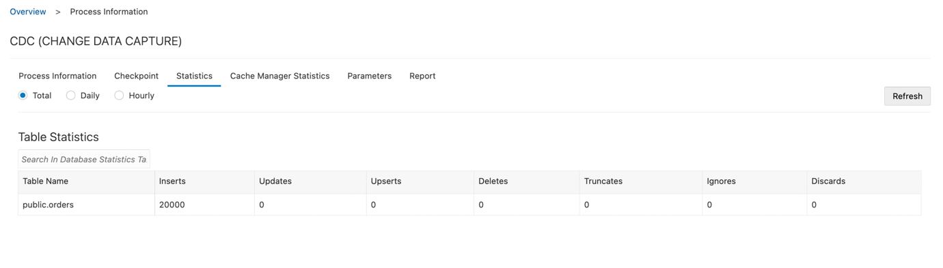

6. Create an Initial Load Replicat on OCI pgsql (T) using the same trail file as step 4.

Add Checkpoint Table to the OCI Target Database

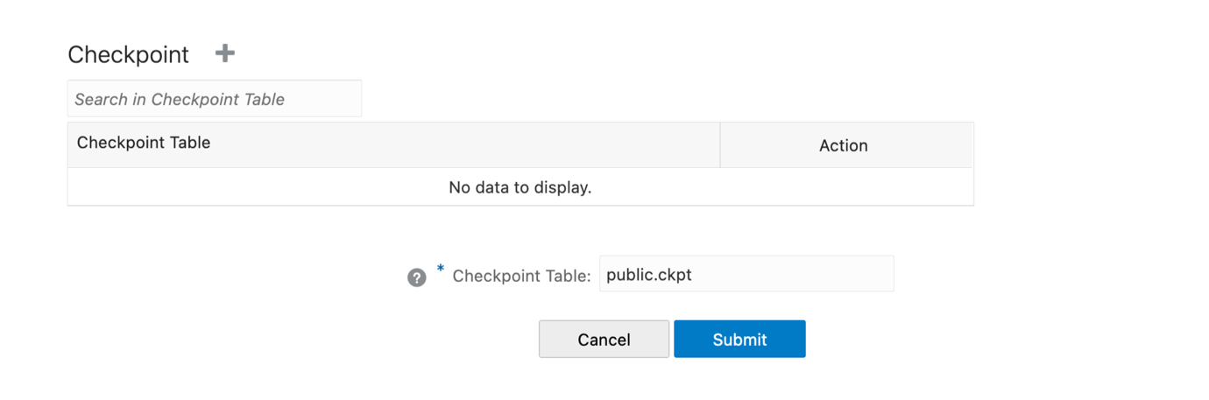

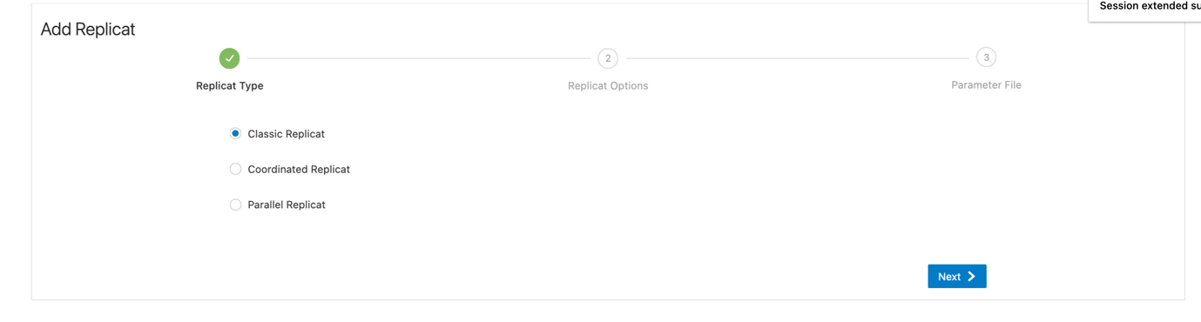

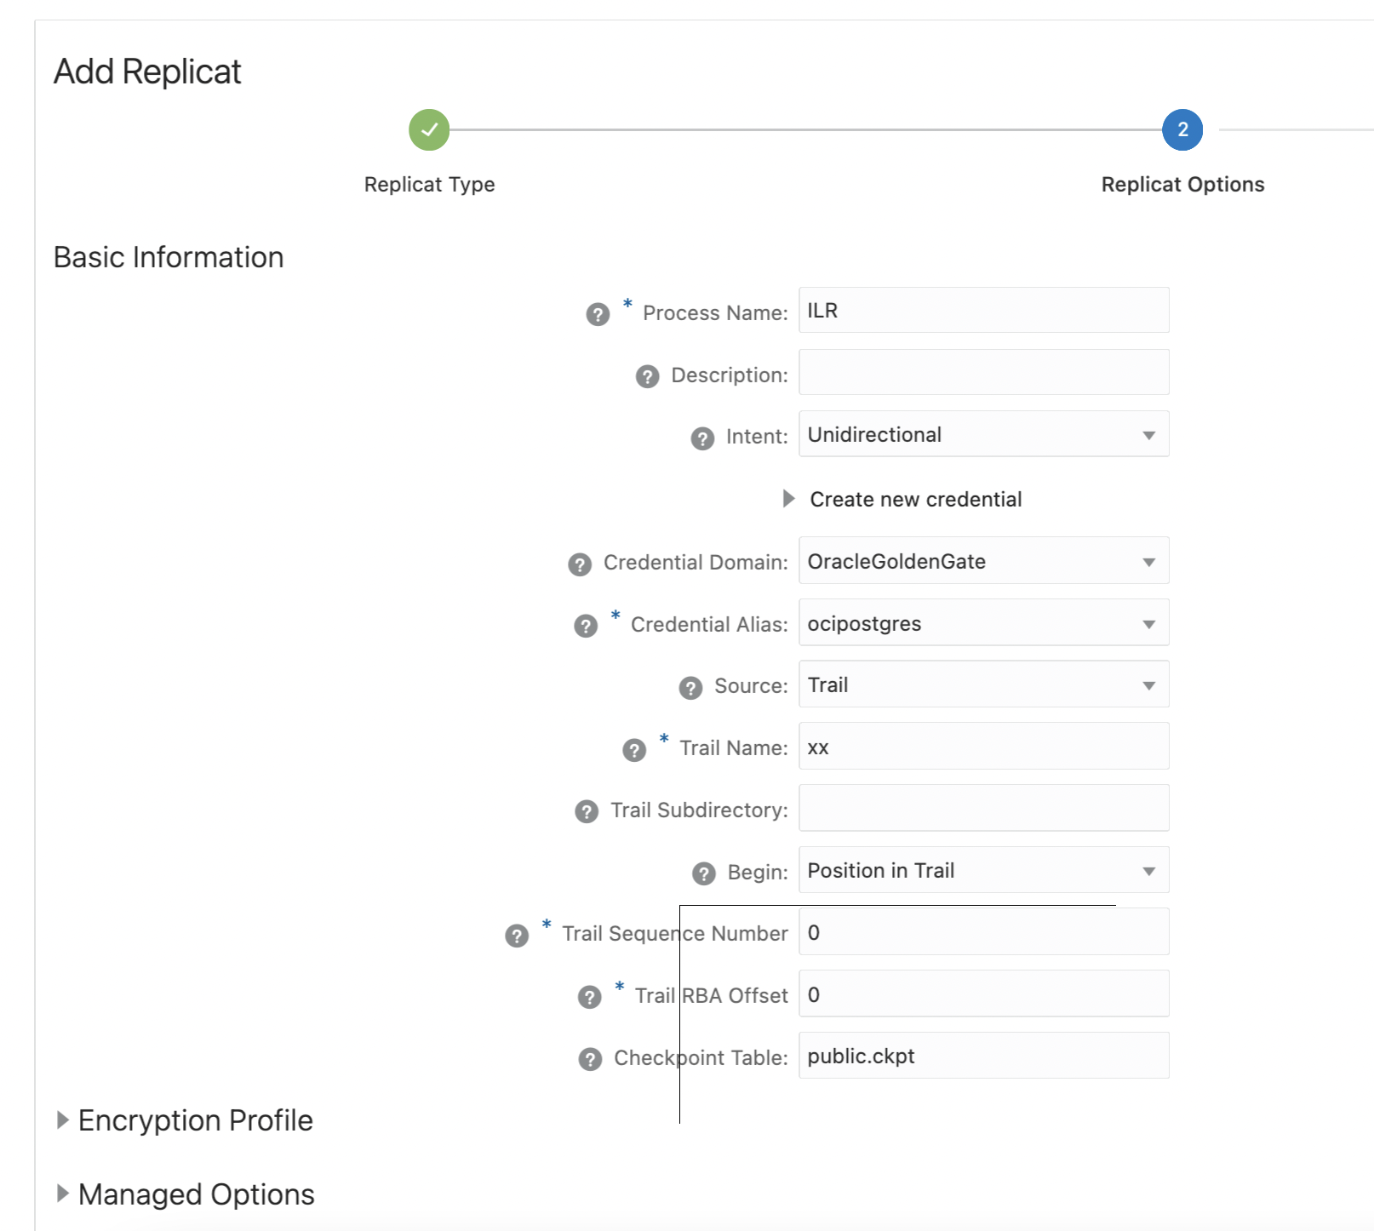

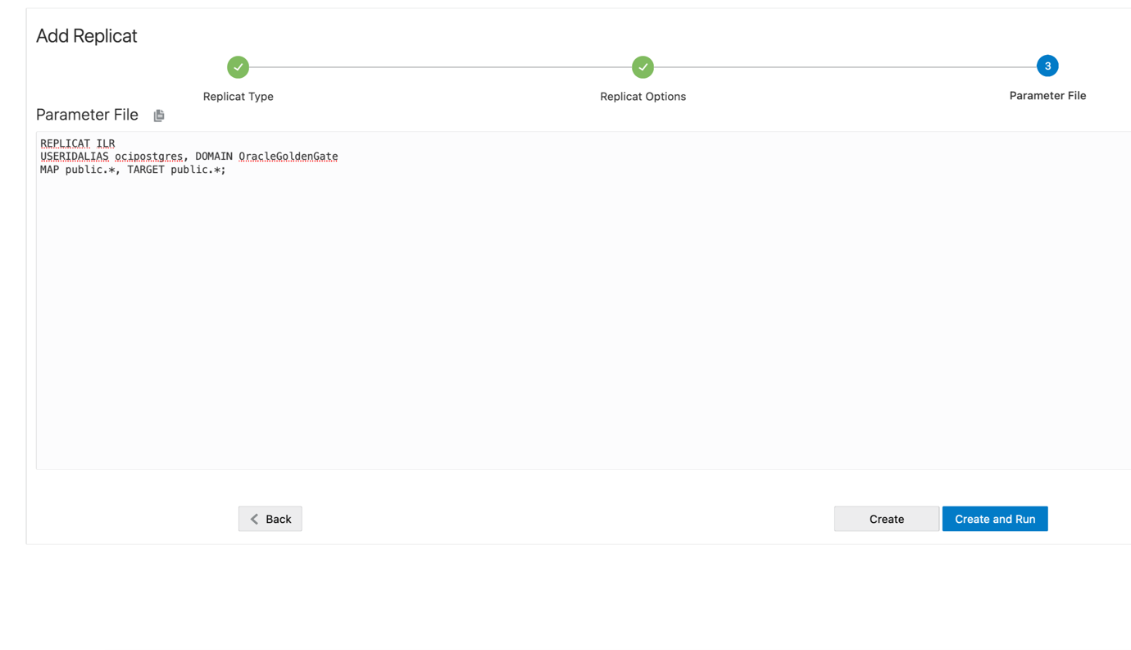

We have now completed the initial load restore. Check the statistic on ILR and verify tables on OCI Postgres
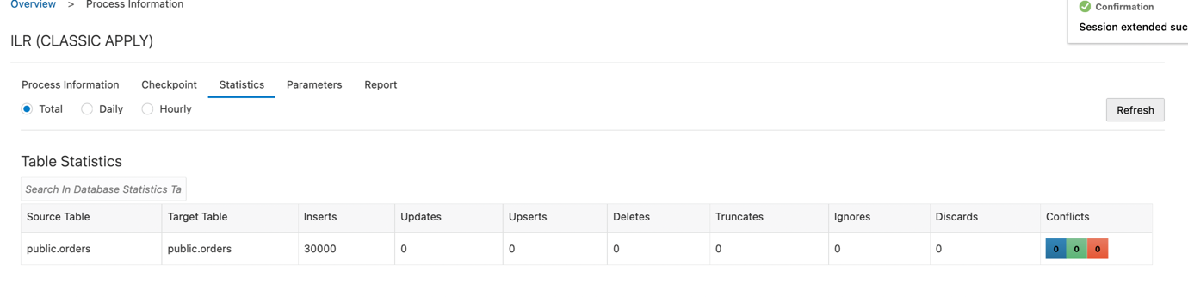
postgres=> select count(*) from orders;
count
-------
30000
(1 row)
Once the Initial load is completed on target, after verifying the statistics you can shut down the initial load replicat

7.Create a CDC Replicat on on OCI Pgsql (T) using the same trail file as step 6.

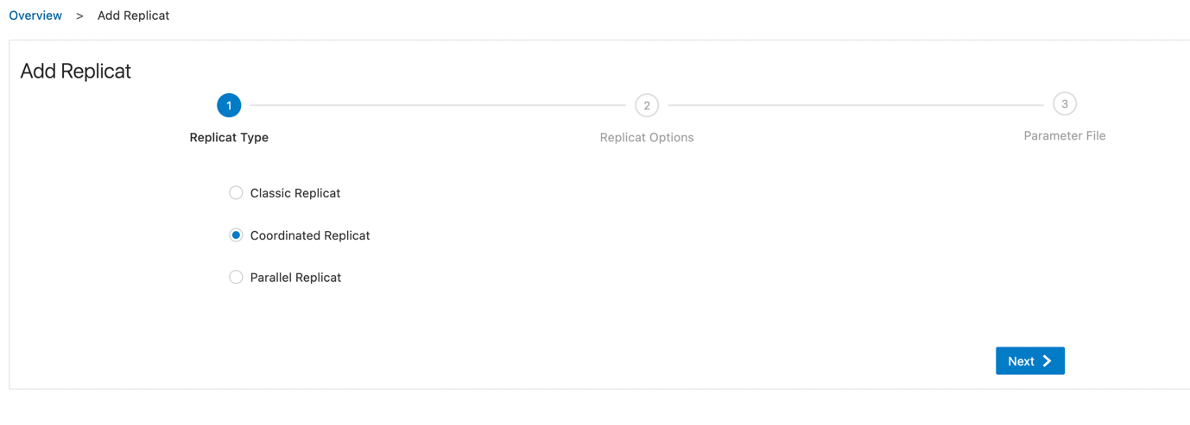

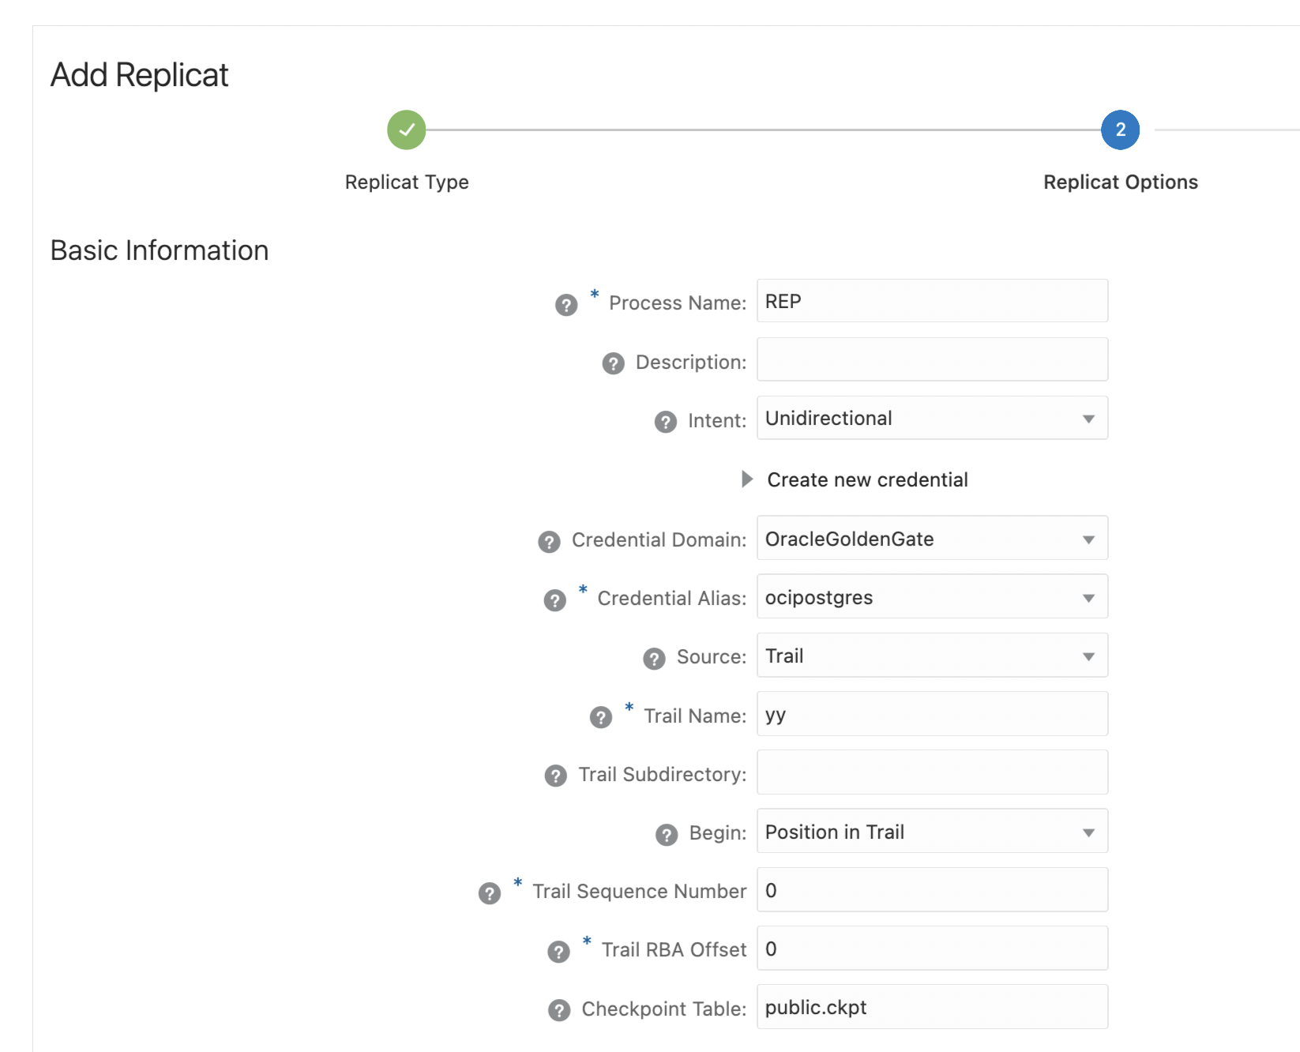

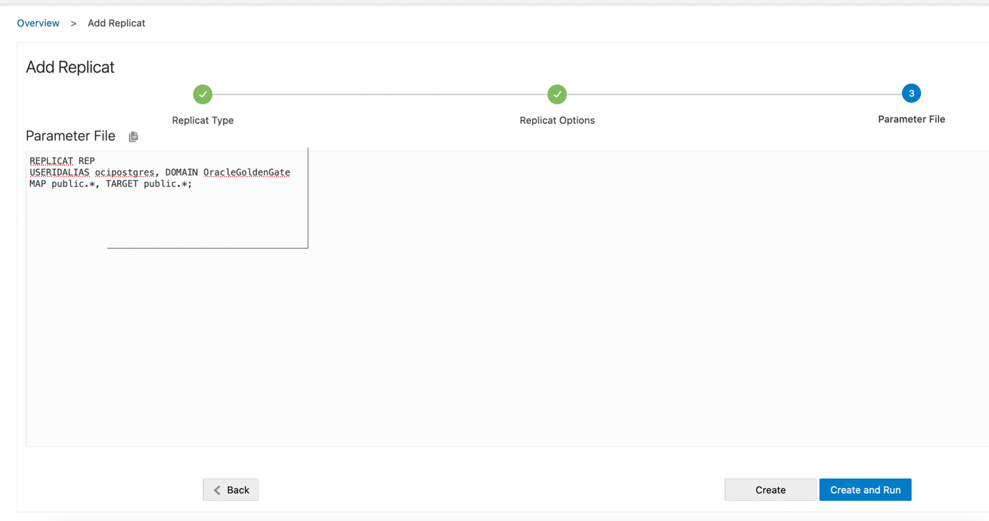
We have now completed the initial load and established a cdc pipeline from AWS RDS Postgres to OCI Postgres. Let’s check the statics on the cdc replicat and also verify from the target RDS Postgres db
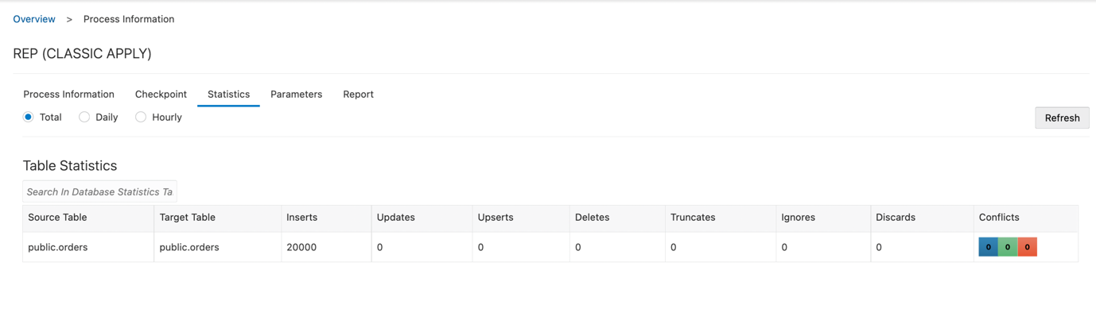
postgres=> select count(*) from orders;
count
-------
50000
(1 row)
Summary:
We first did an initial load extract of 30k transactions (trail file xx) and added the cdc extract (trail file yy) and captured 20k transactions. Then we created an initial load replicat (trail file xx) to load the 30k transactions and then a cdc replicat (trail file yy) was started, which then keeps both RDS and OCI Postgres in sync.
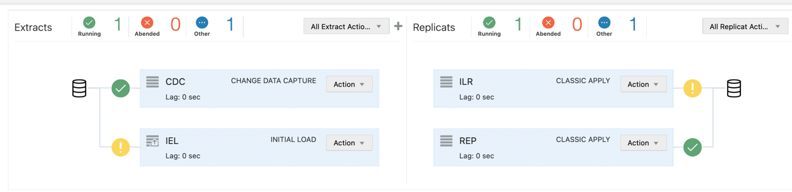
Once the transactions have caught up from AWS to OCI, you can then perform switchover of your application and point to the new OCI Postgres instance.
Post migration activities:
  - Verify the row counts of all the tables comparing the source and target database.
  - Set passwords for the users created in the OCI Database with PostgreSQL database system
  - Run VACUUM ANALYZE on each database or individual tables to update the stats of the databases. This command helps the PostgreSQL query planner create optimized query plans, resulting in better performance.

References:
[1] Precise instantiation for OCI Goldengate for PostgreSQL
https://docs.oracle.com/en/middleware/goldengate/core/21.3/gghdb/add-initial-load-extract-postgresql.html#GUID-C034223A-0EC9-4C48-97F9-8469CB797235
[2] Seamlessly migrate an on-premise PostgreSQL database to OCI Database with PostgreSQL using OCI GoldenGate
https://blogs.oracle.com/dataintegration/post/seamlessly-migrate-an-onpremise-postgresql-database-to-oci-database-with-postgresql-online-with-oci-goldengate
[2] PostgreSQL Replication with OCI Goldengate https://blogs.oracle.com/dataintegration/post/postgresql-to-autonomous-database-replication-using-goldengate
[3] Add PostgreSQL Extract
https://docs.oracle.com/en/cloud/paas/goldengate-service/aemli/#articletitle
[4] Prepare Postgres Database for Goldengate https://docs.oracle.com/en/middleware/goldengate/core/21.3/coredoc/prepare-postgresql.html#GUID-0A4074DF-8A0B-4394-A184-106B81DACEBB
[5] What is supported, and what is not supported on Oracle Goldengate for Postgres
https://docs.oracle.com/en/middleware/goldengate/core/21.3/coredoc/prepare-postgresql-understanding-whats-supported.html#GUID-40CA8909-CEDD-4748-8C92-93E9EC6064FA

